**Polarisation : (of light)**

* Polarization is a property applying to **transverse waves** that specifies the **geometrical orientation** of the oscillations.
* A light wave is an [electromagnetic wave](http://www.physicsclassroom.com/Class/waves/u10l1c.cfm#emmech) . Light waves are produced by **vibrating electric charges .**
* Unlike a usual slinky wave, the electric and magnetic vibrations of an electromagnetic wave occur in numerous planes. A light wave that is vibrating in more than one plane is referred to as **unpolarized light.**
* Light emitted by the sun, by a usual lamp or by a candle flame is unpolarized light. Such light waves are created by electric charges that vibrate in a variety of directions, thus creating an electromagnetic wave that vibrates in a variety of directions.

There are a variety of methods of polarizing light:

### 1.Polarization by Use of a Polaroid Filter:

 When unpolarized light is transmitted through a Polaroid filter, it emerges with one-half the intensity and with vibrations in a single plane; it emerges as polarized light.

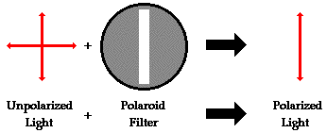

### The filter can be thought of as having long-chain molecules that are aligned within the filter in the same direction.

### 2.****Polarization by Reflection****

### Unpolarized light can also undergo polarization by reflection off of nonmetallic surfaces. The extent to which polarization occurs is dependent upon the angle at which the light approaches the surface and upon the material that the surface is made of.

### 

### A person viewing objects by means of light reflected off of nonmetallic surfaces will often perceive a glare if the extent of polarization is large.

### 3.****Polarization by Refraction****

### 

### The refracted beam acquires some degree of polarization. Most often, the polarization occurs in a plane perpendicular to the surface.

### 4.****Polarization by Scattering****

Polarization also occurs when light is scattered while traveling through a medium. When light strikes the atoms of a material, **it will often set the electrons of those atoms into vibration**. The vibrating electrons then produce their own electromagnetic wave that is radiated outward in all directions. This newly generated wave strikes neighbouring atoms, forcing their electrons into vibrations **at the same original frequency**. These vibrating electrons produce another electromagnetic wave that is once more radiated outward in all directions. This absorption and reemission of light waves causes the light to be scattered about the medium.

**DIFFRACTION: (of light)**

We classically think of light as always traveling in straight lines, but when light waves pass near a barrier they tend to bend around that barrier and become spread out. Diffraction of light occurs when a light wave passes by a corner or through an opening or slit that is physically the approximate size of, or even smaller than that light's wavelength.

The diffracting object or aperture effectively becomes a secondary source of propagating wave. If the opening is much larger than the light's wavelength, the bending will be almost unnoticeable.

An optical effect that results from the diffraction of light is the silver lining sometimes found around the edges of clouds. Optical effects resulting from diffraction are produced through the interference of light waves. To visualize this, imagine light waves as water waves. If water waves were incident upon a float residing on the water surface, the float would bounce up and down in response to the incident waves, producing waves of its own. As these waves spread outward in all directions from the float, they interact with other water waves.

If the crests of two waves combine, an amplified wave is produced (constructive interference).

However, if a crest of one wave and a trough of another wave combine, they cancel each other out to produce no vertical displacement (destructive interference).

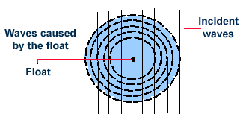

**INTERFERENCE:**

An important characteristic of light waves is their ability, under certain circumstances, to interfere with one another. Most people observe some type of optical interference every day, but do not realize what is occurring to produce this phenomenon. One of the best examples of interference is demonstrated by the light reflected from a film of oil floating on water

Another example is the soap bubble illustrated in Figure 1 that reflects a variety of beautiful colors when illuminated by natural or artificial light sources.

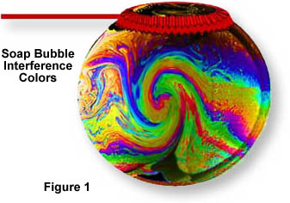

This dynamic interplay of colors derives from simultaneous reflection of light from both the inside and outside surfaces of the bubble. The two surfaces are very close together (they are only a few microns thick) and light reflected from the inner surface interferes both **constructively** and **destructively** with light reflected from the outer surface

Interference colors arising from stressed regions in materials can be easily observed in polarized light. The ruler in Figure 6 is made of plastic and is being observed through crossed polarizers. Under normal light, the ruler appears translucent with its graduations plainly visible. However, when viewed under polarized light, the ruler exhibits stress patterns that appear more profound in areas that are more highly deformed. This is due to a high degree of alignment of the long-chain polymer molecules that comprise the ruler. Note that the greatest degree of birefringence occurs near the hole on the left side of the ruler.

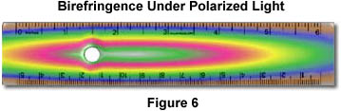

**Holograms** also depend upon interference to produce their three-dimensional-like images. In reflection holograms, both a reference and object-illuminating beam are reflected onto a thick film from opposite sides. These beams interfere to produce light and dark areas that correspond to an image that appears three-dimensional. Transmission holograms use both the reference and object-illuminating beams on the same side of the film to produce a similar type of effect.

